How the Interject mixes with water, not with Petrol
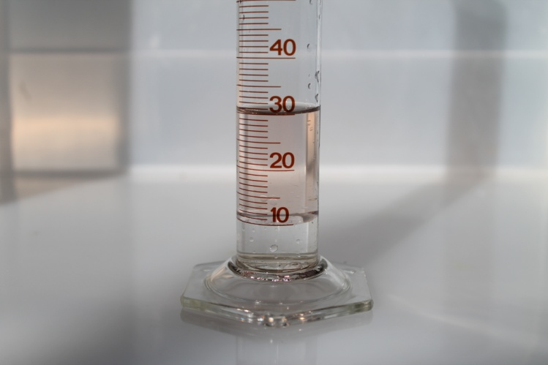 | This Photo shows the test tube with approx. 20 mls of petrol suspended on top of 10 mls of water. (This is why it works so well as water is at the bottom of the fuel tank)
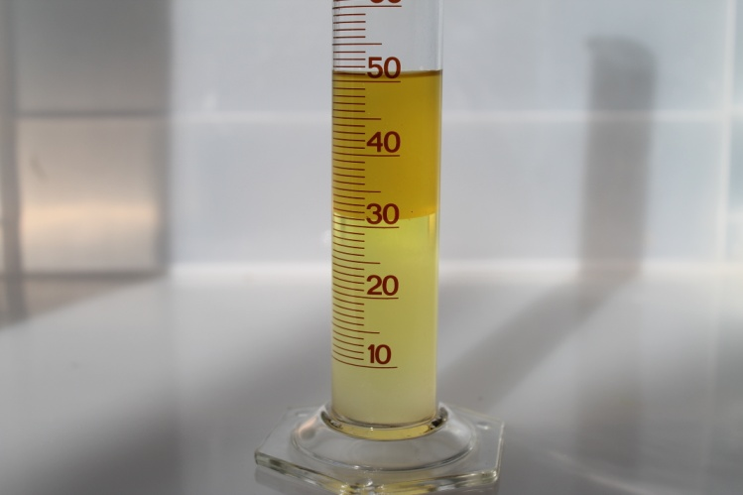 | This photo shows that 20 mls of Interject chemical has been added to the test tube, and although it has coloured the petrol, it has not added to the petrol, but increased the bottom section by 20 mls to now have 30mls of water and Interject emulsion.  (And this will burn during combustion)
And..The best….  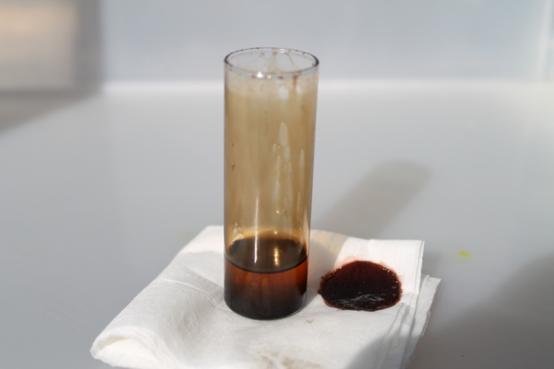  This test tube has had sulphuric acid added to the petrol to simulate contaminated fuel and the subsequent carbon stain to the right of the glass. | Acid Neutralisation  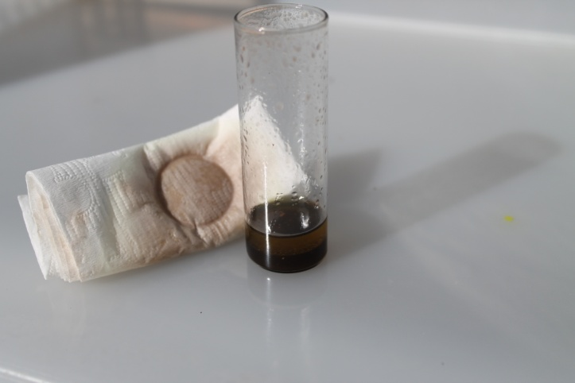  This is the same test tube as on the left but after the interject has been added.  The cleanliness of the test tube is clearly visible… and the acid contamination has been completely neutralised.

Partial blockages of injectors will often be cleared within 15 mins of adding the Interject Chemical, and all these tests can be reproduced in any workshop environment.

